**Product category:** R-stud 23 mil drywall stud

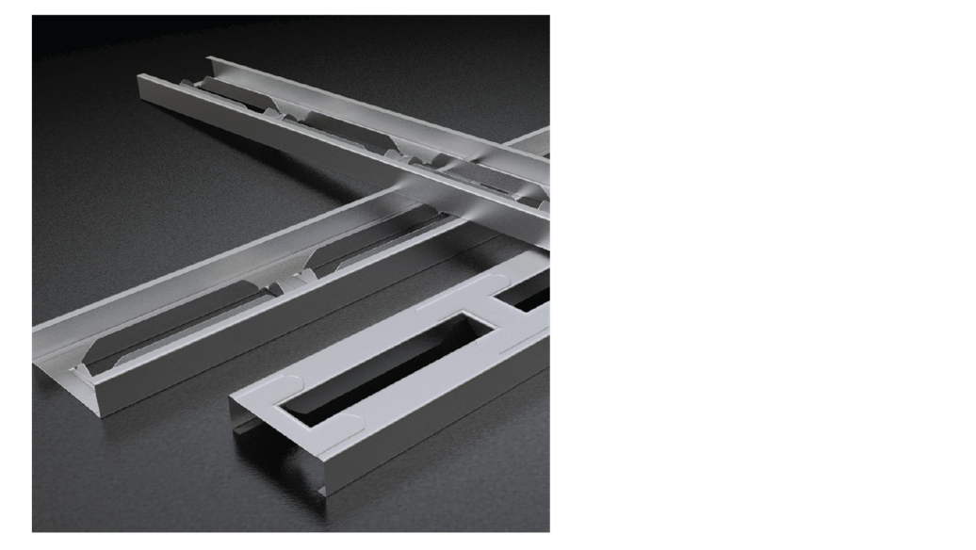**Product name:** 400-RS-137-23 50Ksi G60  
 4.00” R-stud

**Drywall Stud**

Coating: G60

Color coding: White

**Geometric Properties**

Web depth 4.00 in Weight 0.59615-lb/ft

Flange width 1.375 in Web opening length 9-13/16-in

Stiffening lip 0.375 in Web opening width 2.0-in

Design thickness 0.0241 in Minimum thickness 0.023 in

Yield stress, Fy 50 Ksi

**Gross Section Properties of Full Section, Strong Axis**

Cross sectional area (A) [0.17534-in^2]

Moment of inertia (lx) [0.45089-in^4]

Radius of gyration (Rx, r1) [1.6036-in]

Moment of inertia (ly) [0.03790-in^4]

Radius of gyration (Ry, r2) [0.4649-in]

Max bending moment Ix (Maxo) [6.2454-k-in]

Web openings (not punch-outs) formed from web every 12 in. with Stamping at bridge every 12 in.

Max bending moment Iy (Maxo) [1.5142-k-in]

Allowable shear force in web (Vax) [1.2732-k]

ASTM & Code Standards:

* ATI/Intertek CCRR 1073
* IBC 2012 Compliant
* AISI S-100 & S220-11
* ASTM E119, E72, E90
* ASTM AC86, C645, & C745
* U.S. Patent Numbers:

USP-7866112  
USP-7743578  
USP-8424266

**Tension/Compression Properties**

Warping constant (Cw) [0.0076975-in^6]

Distance from shear center to neutral axis (Xo) [-0.8977-in]

Radii of gyration (Ro) [1.8956-in]

Torsional flexural constant (Beta) [FEA-in^4]

Compression Pao(max) [4.1052-k]

Tension Tao (Ta) [6.1369-k]

Unbraced Length (Lu) [full]

**Notes:**

* Calculated properties are based on Supported specifications.
* Effective properties herein incorporate the increased strength from cold working of the steel while forming. We only use 50Ksi coils.
* Tabulated properties, including torsional properties, are based on the added cross section properties of the web openings and indents as

R-studs do not have punch-outs.

* Maxo Allowable moment includes cold work of forming
* Maxo Allowable moment is taken as the maximum value based on local or distortional buckling.
* For deflection calculations use the moment of inertia.
* Web opening is every 12 inches and are 9-13/16 inches long with flanges opening out of web. Corners of the web openings are enhanced with flared reliefs.

**Sustainability-** Steel is one of the most sustainable building materials in the world. It is recycled content, recyclable again and again, durable, safe, zinc coated, dimensionally stable and strong, as well as not susceptible to rot, termites, or mold.

Supported specifications:

* 2016 AISI - ASD, LRFD, and LSD
* 2012 AISI - ASD, LRFD, and LSD
* 2010 AISI - ASD, LRFD, and LSD
* 2007 AISI - ASD, LRFD, and LSD
* 2004 AISI - ASD, LRFD, and LSD
* 2001 AISI - ASD, LRFD, and LSD
* 1999 AISI - ASD and LRFD
* 2002 ASCE - ASD and LRFD (stainless steel)

**Product category:** [insert category]

**Product name:** [insert name]  
 [insert info]

**[400RS137-23-50Ksi G60] On 16 inch spacing**

**[insert title]**

|  |  |  |  |  |  |  |  |  |  |
| --- | --- | --- | --- | --- | --- | --- | --- | --- | --- |
| Spacing  (inches) | 5 psf | | | 7.5 psf | | | 10 psf | | |
| L/120 | L/240 | L/360 | L/120 | L/240 | L/360 | L/120 | L/240 | L/360 |
| 16 | 20’7” | 17’11” | 16’4” | 16’3” | 14’2” | 12’11” | 14’3” | 12’6” | 11’4” |

Non-Composite Table Notes:

* [insert]

**[400RS137-23-50Ksi G60] 0n 24 inch spacing**

**[insert title]**

|  |  |  |  |  |  |  |  |  |  |
| --- | --- | --- | --- | --- | --- | --- | --- | --- | --- |
| Spacing  (inches) | 5 psf | | | 7.5 psf | | | 10 psf | | |
| L/120 | L/240 | L/360 | L/120 | L/240 | L/360 | L/120 | L/240 | L/360 |
| 24 | 17’11” | 15’9” | 14’3” | 14’1” | 12’9” | 11’6” | 12’7” | 10’11” | 9’10” |

Non-Composite Table Notes:

* [insert]